Write a matlab pgm to perform convolution of the following discrete s/gs

% Discrete

x3(n)=1 ; 1 < n < 10

x4(n)=1 ; 2 < n < 10

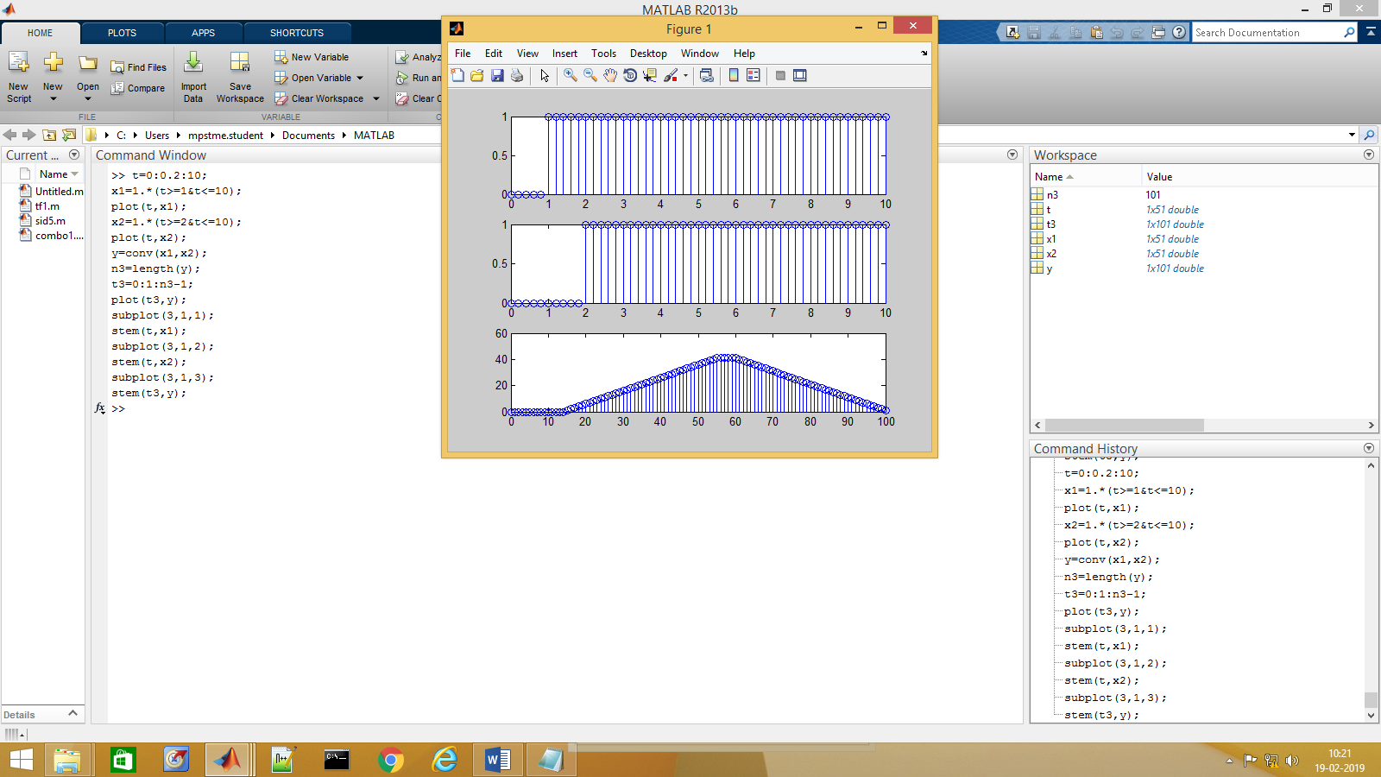

t=0:0.2:10;

x1=1.\*(t>=1&t<=10);

plot(t,x1);

x2=1.\*(t>=2&t<=10);

plot(t,x2);

y=conv(x1,x2);

n3=length(y);

t3=0:1:n3-1;

plot(t3,y);

subplot(3,1,1);

stem(t,x1);

subplot(3,1,2);

stem(t,x2);

subplot(3,1,3);

stem(t3,y);